5- Methodology Comparison

(2023). Improving digital signature verification accuracy through support vector machine learning: a comparative study. International Journal of Advances in Scientific Research, doi: 10.37547/ijasr-03-05-11

For signature verification, the three most common machine learning models are linear SVM, polynomial SVM and RBF SVM. The RBF SVM had 98% accuracy rate which is the highest among all other model.

• SVM-base approaches, lead to an increase in accuracy of digital signature verification.

• RBF SVM method is the best and ensures 98% accuracy level.

• SVM-based techniques result in better digital signature authentication performance.

• RBF SVM method proved to be most effective with 98% accuracy.

• Linear SVM: 95% precision.

• RBF SVM: 98% accuracy ability, the most efficient method.

• SVM-based techniques that increase the accuracy of digital signature verification are introduced.

• A comparative study of linear, polynomial and RBF SVM models.

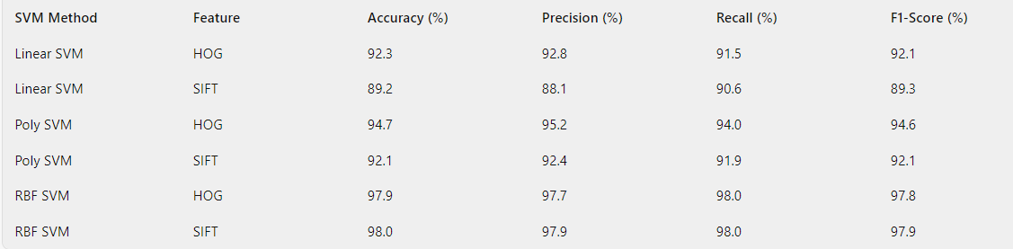

Ibraheem, M., Alharbi. (2023). Efficient Handwritten Signatures Identification using Machine Learning. International Journal of Advanced Computer Science and Applications, doi: 10.14569/ijacsa.2023.0140316

Signature verification widely uses the K-nearest neighbors (KNN) classifier, which increases accuracy and performance as compared to previous methods.

• I explored different signature recognition algorithms that were implemented using Fourier Descriptors and HOG features.

• Class coincidence in authentication gets problem in signature recognition recognized.

• Improved Signature Authentication Using Fourier Descriptors and HOG Features.

• LBP features for attractive signatures recognition but with low false acceptance rate.

• 10% of test signatures was failing to be rejected, FAR of 0.169.

• The KNN classifier depicted higher FAR's and recognition accuracies.

• The FAR is high which is 0.169.

• For the KNN classifier, higher FAR and identification accuracy was given.

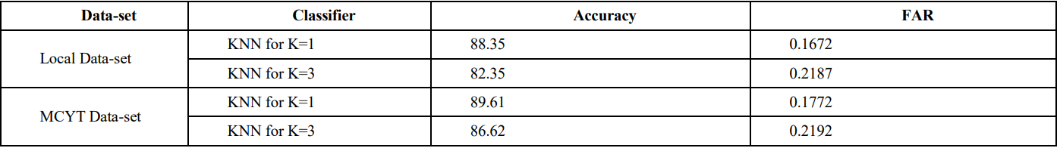

Zainab, Hashim., Hanaa, Mohsin, Ahmed., Ahmed, Al-Hayat. (2022). A Comparative Study among Handwritten Signature Verification Methods Using Machine Learning Techniques. Scientific Programming, doi: 10.1155/2022/8170424

The most commonly used machine learning techniques for signature verification include SVM, Random Forest, and Neural Networks. They differ in terms of accuracy and efficacy, with SVM usually being on when executing this operation.

• Machine learning approaches have dominated the handwritten signature authentication domain because of their efficiency.

• The report covers the whole field in terms of studies.

• Authenticating signature using machine learning for genuine v/s forged classification.

• Scrutiny of the research that has been done on the online/offline handwritten signature verification methods.

• This article focuses on the current literature and the outcome of all the latest research on handwritten signature verification.

• The paper compares two systems based on datasets, feature extraction, and classification methods.

• Table of constraints of machine-learning methods in signature verification.

• Problems in dataset construction, feature extraction, and classification methods emphasized.

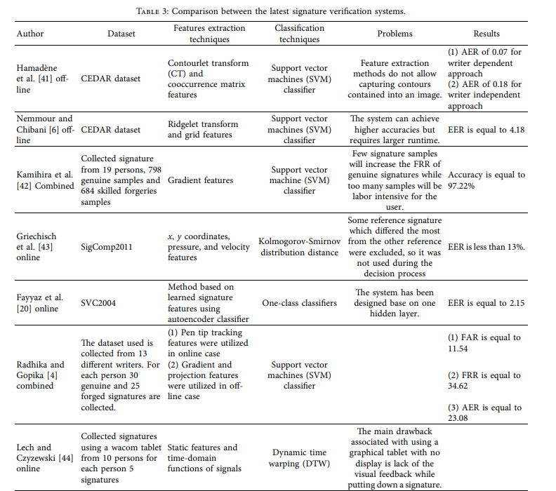

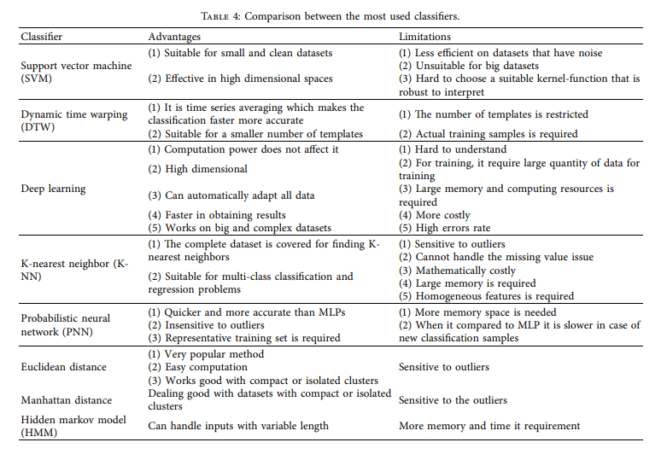

References:

1. <https://sciencebring.com/index.php/ijasr/article/view/225>
2. <https://thesai.org/Publications/ViewPaper?Volume=14&Issue=3&Code=IJACSA&SerialNo=16>
3. <https://www.hindawi.com/journals/sp/2022/8170424/>
4. <https://link.springer.com/chapter/10.1007/978-3-540-76280-5_15>